|  |
| --- |
| As well as your written report, you will give a spoken presentation of the highlights of your research, in which each member of the research team speaks for a maximum of four minutes. At the end of the presentation, there will be time for Q & A.  This unit gives suggestions on how to deliver an effective academic presentation. |

**Warm-up: Discussion**

As a student, you have listened to many spoken academic presentations (by professors, instructors, classmates…) Talk to one or more classmates about:

* what makes a presentation effective/enjoyable
* what makes a presentation ineffective/not enjoyable

You may want to consider:

* Content
* Language
* Organization
* The speaker’s voice
* Speaking speed
* Use of PowerPoint or other visual aids
* Body language
* Eye contact

You can use the space below to make notes.

|  |  |
| --- | --- |
| **Qualities of an effective/enjoyable presentation** | **Qualities of an ineffective/non-enjoyable presentation** |
|  |  |

**Task 1: Listening & Discussion**

1. Watch the following YouTube clip of an ineffective presentation (up to 00:04:17). As you watch, make notes about what the speaker does poorly.

<https://www.youtube.com/watch?v=ATfY8dvbuFg>   
(bad presentation example - University of Bedfordshire)

1. With a partner, discuss what you noticed.
2. Now watch the remaining 35 seconds of the clip. How many of the suggested ideas did you notice? Did you notice any flaws in the presentation which are not mentioned in the clip?
3. Now watch an example of a good presentation by the same speaker (up to 00:06:37). As you watch, make notes about what the speaker does well.

<https://www.youtube.com/watch?v=5utoLhjUuAI>   
(related good presentation example – also University of Bedfordshire).

1. With a partner, discuss what you noticed.
2. Now watch the remaining 20 seconds of the clip. How many of the suggested ideas did you notice? Did you notice any strengths in the presentation which are not mentioned in the clip?

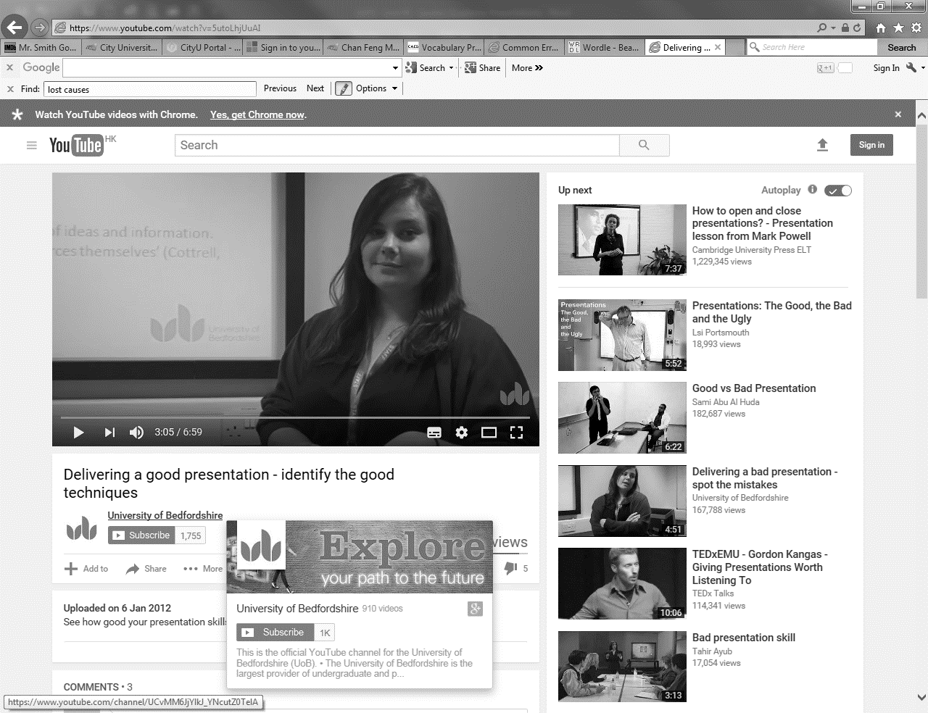



|  |
| --- |
| **Planning Your Presentation**  The first thing you need to think about is what you will include in your presentation. Here are some important guiding questions to ask yourselves:   * What are the most interesting things in your written report? * How much background information will your audience need in order to understand your research topic/focus? * How many of the sources from your Introduction should you include? * How much detail about Methods do you have time for in this presentation? * In the Results part of your presentation, will tables, graphs or charts be useful as visual aids when describing your **questionnaire data**? (This depends on the details of the data you have gathered through your questionnaire.) * What are the most interesting/”attention-getting” quotes from your **interview data**? * What are the most important Discussion elements of your written report?   In the time available to you (four minutes per speaker), it is not possible to include every detail of your written report, so it is important to be selective. |

**Introducing Your Presentation**

**Task 2: Speaking**

With your research partner[s], discuss what you should say at the beginning of your presentation.

|  |
| --- |
| **Useful Phrases for Introducing an Academic Presentation** |
| 6058142799_d4422a8fe2_z[1]“Good morning/afternoon/evening, everyone.”  “Hi, everyone.”  “I’m [David], and this is [Joyce]”.  “Today, we’ll be talking about/telling you about…”  “I’ll be providing the [type of information/sections], and [Kelvin] will take care of…”  “We’ll start off with…”  “Then we’ll go on to discussing…”  “At the end, we’ll be giving you a chance to ask questions.” |

1. Decide what you are going to say as the introduction/overview of your presentation. Practise it a few times with your partner[s], and then take turns practising with other groups.
2. The listeners’ job is to provide constructive feedback. (For example, is there enough eye contact? Is the speaker’s voice energetic and friendly? Is the introduction delivered at a suitable speed? Does the speaker seem eager to communicate?)

**Signposting**

**Task 3: Speaking**

Look at the following list of signposting expressions. Work with your partner[s]. Think of ways to use them in sentences which explain the content of your presentation. Practise saying these sentences.

|  |
| --- |
| **Useful Signposting Expressions** |
| “OK. Moving on to…”  “Let’s now look at…”  … “Or in other words,…”  “I’d like to turn now to….”  “So, to recap,…”  “Let me elaborate on that…”  “I’d like to conclude by pointing out that…” |

**Using Powerpoint Effectively**

**Task 4: Analysis**

Using PowerPoint effectively sometimes involves knowing what **not** to include in your slides. Go to the following web site: [http://grammar.ccc.commnet.edu/grammar/.](http://grammar.ccc.commnet.edu/grammar/) Click on “Peripherals and PowerPoints” >> “PowerPoint Presentations” and download the file called “Clauses: Essential Building Blocks”. What does the presentation include which you think should be avoided in an academic presentation?

|  |
| --- |
| 6058142799_d4422a8fe2_z[1]PowerPoint can be used to highlight information in a table containing data. You can show one slide containing the table, and then duplicate the slide, with certain details highlighted by using different colours or font sizes. This can be a helpful way of drawing your audience’s attention to specific details. |

**Task 5: Language Focus**

Here are some useful expressions to use when you are presenting tables, graphs or charts. Work with your research partner[s] and practise using these expressions to describe your research findings.

|  |
| --- |
| **Useful Expressions for Describing Tables, Graphs and Charts** |
| “Have a look at Table 1.”  “I’d like to draw your attention to Figure 2.”  “Let’s look at Table 3.”  “This graph shows…”  “As you can see in the graph,…”  “There’s a clear difference between [finding 1] and [finding 2].”  “Notice the similarity between [finding 1] and [finding 2].”  “As this chart shows,…”  “What do these numbers tell us? Well, it could be that…” |

**Dealing with Q & A**

**Task 6: Language Focus**

Dealing with questions from the audience is an important part of an academic presentation. Look at the following jumbled sentences and put the words into a logical order.

1. questions/have/does/any/anyone?

2. question/a/good/that’s

3. that/for/thanks/out/pointing

4. your/I’m/I/question/sure/understand/not

5. questions/there/other/any/are?

|  |
| --- |
| **Extra Help For Your Presentation**  The ELC can help you to prepare for your presentation in various ways:   * You can book a session in the Speaking Studio. * You can attend Presentation Skills workshops. * You can use the online material in the ELSS website.   For more information, go to <http://elss.elc.cityu.edu.hk/ELSS/home.aspx>. |